(For all content)

https://github.com/mattdavis0351/mongodb-labs/blob/master/exercises/02_intermediate-mongo-queries.md

1 ) Comparison Operators

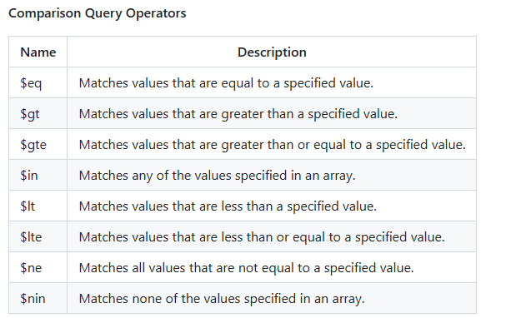

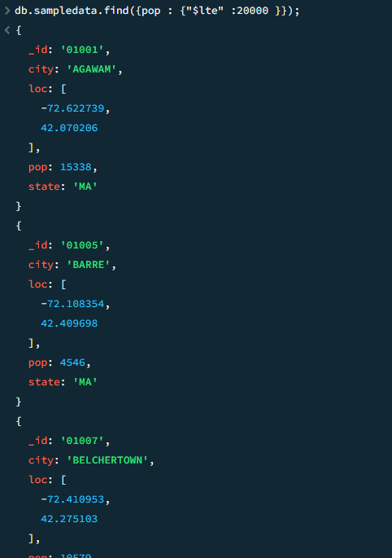

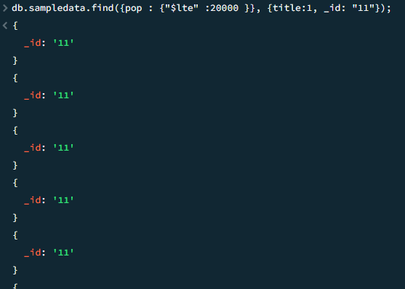

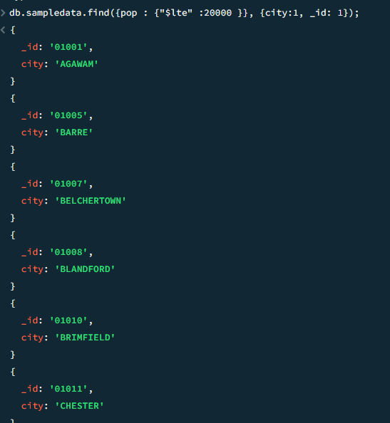

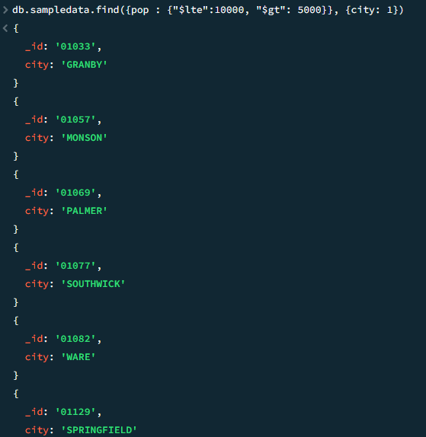

**The "$ne" query operator**

ne stands for **not equal**. Therefore the use of this operator filters out records where the matching condition is not true.

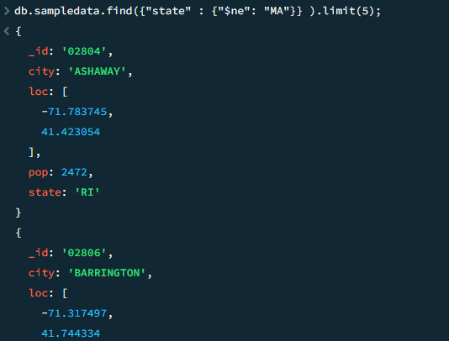

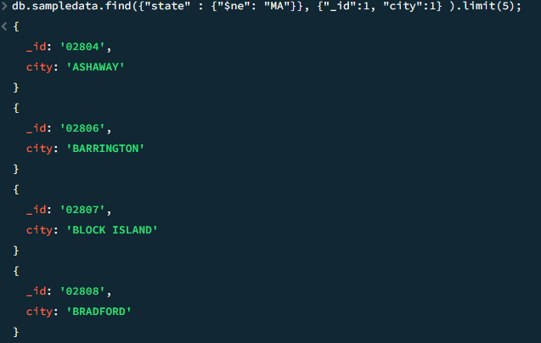

### The "$in" query operator

The $in operator allows us to specify 1 or more values in an array. If any 1 of those filter conditions is matched, a resulting document is returned.

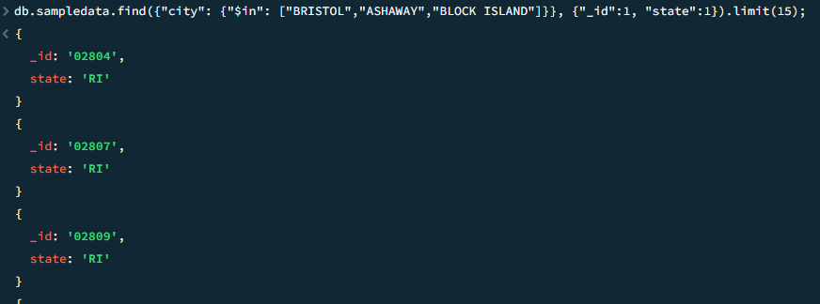

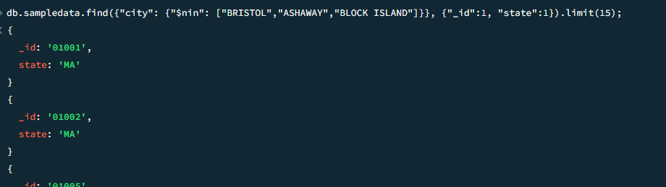

$nin = not in

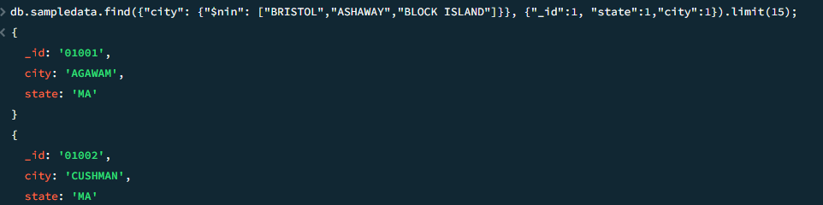

2) Logical Operators

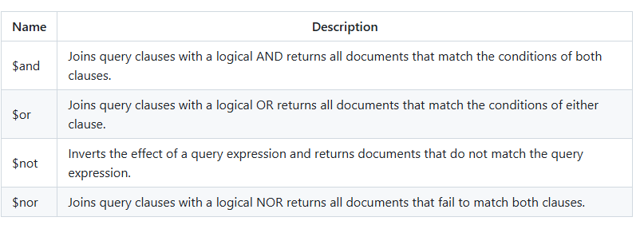

### The "$or" operator

This operator **OR**s the filters stated in a query and returns documents where atleast 1 of the filters is true.

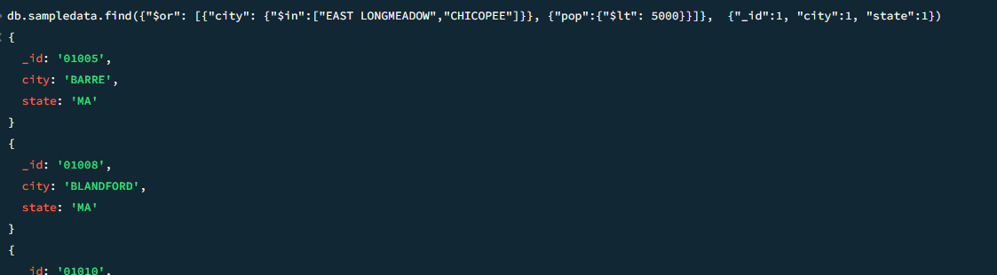

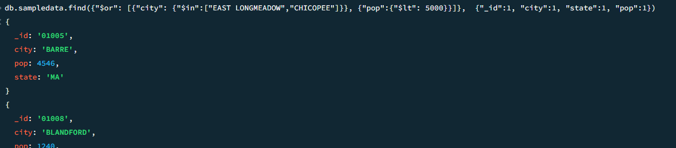

3) Element Operators

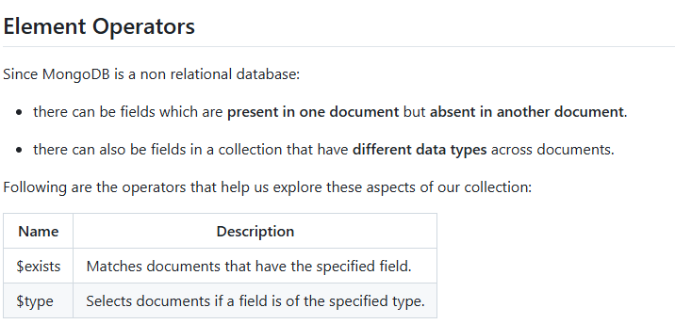

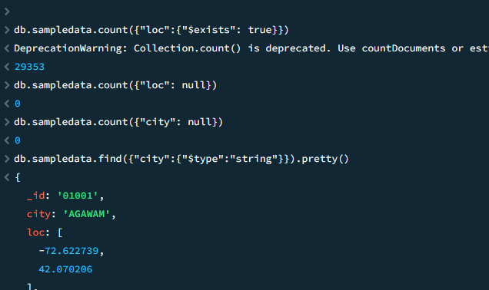

**4) Array Operators**

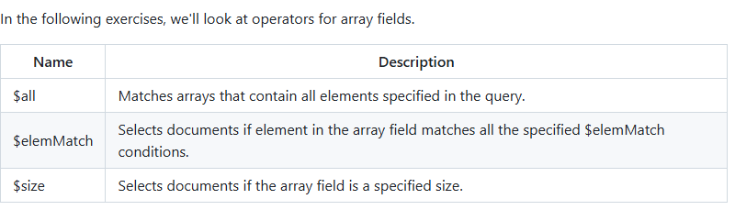

### The "$all" query operator

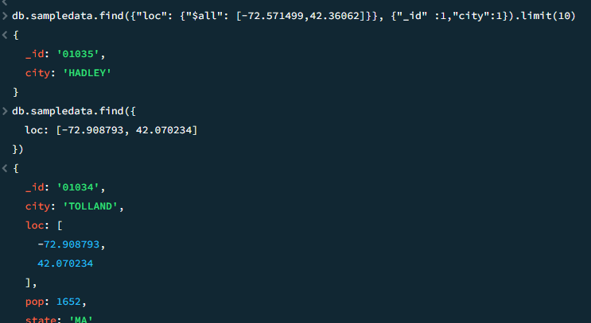

### The "$elemMatch" query operator

One of the more powerful operators for arrays is $elemMatch. It matches array elements which are present in the same position and is best explained through an example.

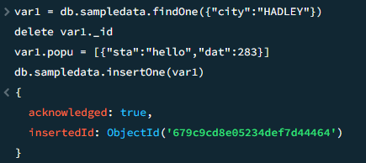

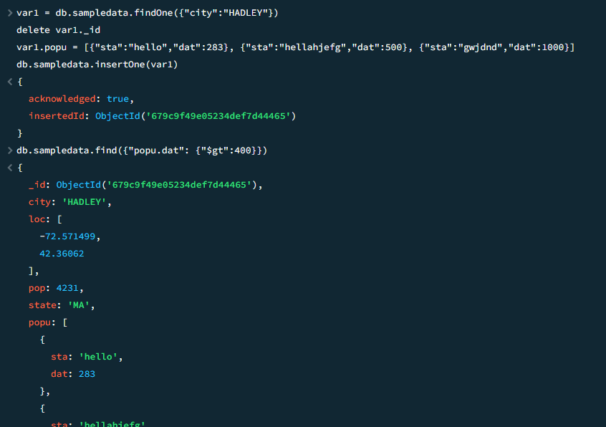

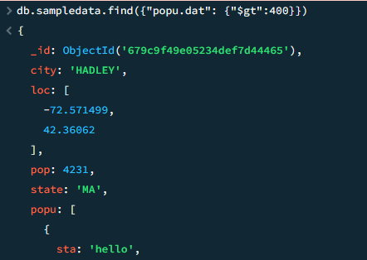

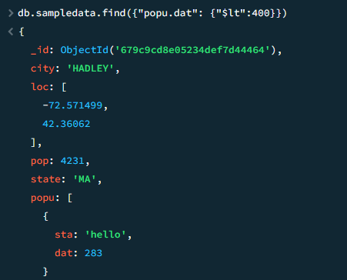

### The "$size" query operator

As the name suggests, this operator deals with the length of an array.

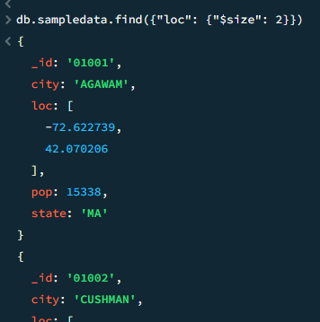

Aggregate

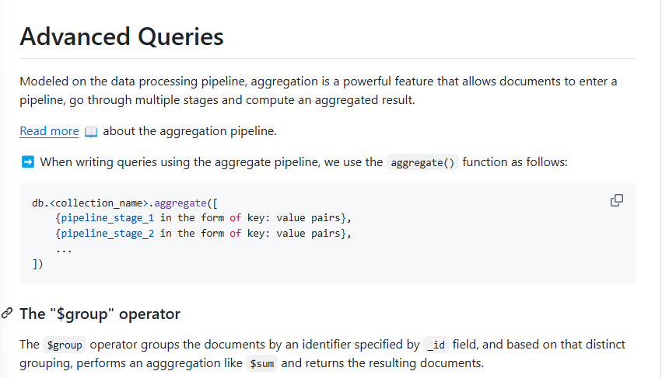

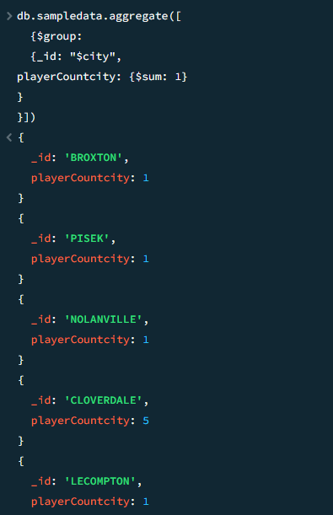

### The "$match" operator

The $match operator matches input documents to a given criteria and passes those matched documents to the next stage of the pipeline.

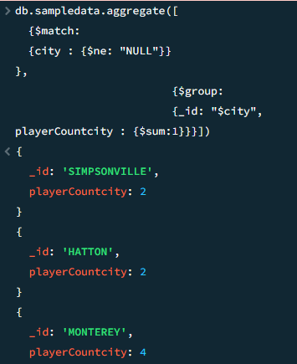

### The "$sort" operator

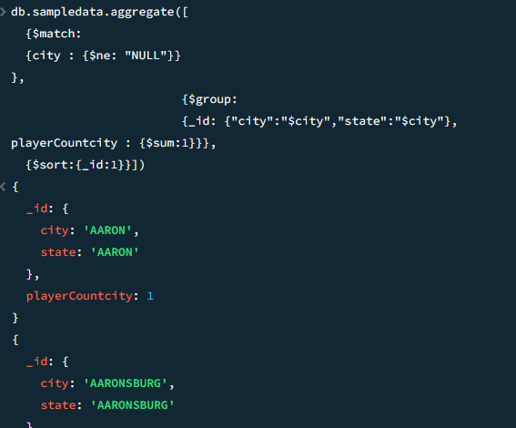

### The "$unwind" operator

The $unwind operator deconstructs an array resulting in a document for **each** array element. The concept will become more evident through the exercise.

